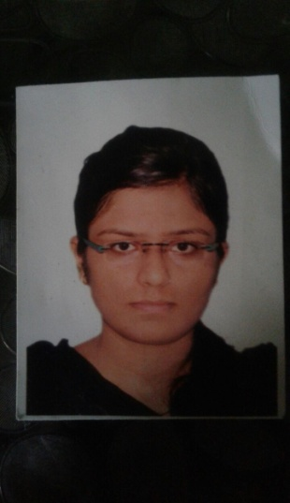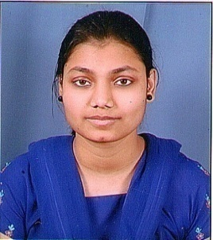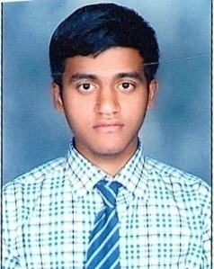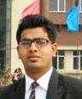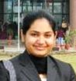

***Chancellor’s awardees***

***Jasmine Ghuldu Ajay Singh Ajay Patel***

***Vivek Soni Naureen Ali Arpita Tiwari***